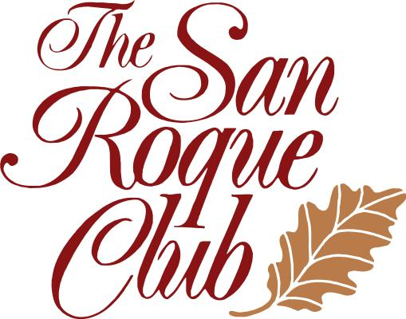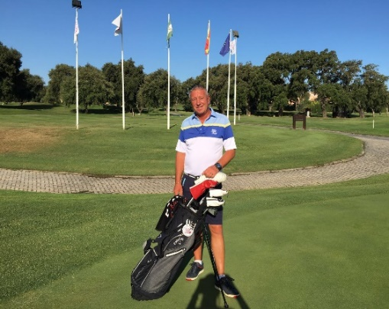
Enjoy Playing Better Golf
Professional Golf Training
With
Head PGA Professional Mark Emery
(British & German PGA Member)
At the San Roque Golf Club Academy
(German also spoken)
We offer both individual and group training on Swing Analysis, Short Game, Putting,
Golf Course Management & Mental Training.
We use modern teaching technologies such as TRACKMAN, EXPLANAR and Video Analysis.
We have fantastic training facilities including a covered Driving Range.
Callaway Fitting Center
The new 2017 models have already arrived!

We look forward to welcoming you at the San Roque Golf Club!
Contact: markemerypro@aol.com or markemerypro@sanroqueclub.com
Mobile: +34 676 471 912

The San Roque Club, A-7Km. 127, 11360 San Roque (Cadiz), Spain
www.sanroqueclub.com
Spass am Golf
durch professionelles Golf Training
mit
Head Professional Mark Emery
(British PGA, German PGA)
In der San Roque Club Golf Academy
Unterricht in Deutsch und Englisch
Wir bieten individuelles Training, Gruppentraining, Kurzspielkurse, Putting Kurse, Golf Course Management, Mental Training
Moderne Lehrmethoden mit TRACKMAN, EXPLANAR und Video Analyse.
Fantastische Trainingsmöglichkeiten, überdachte Driving Range,

Callaway Fitting Center
Die neuen Modelle 2017 sind eingetroffen!
Vereinbaren Sie einen Termin für ein individuelles Schlägerfitting

Kontakt: markemerypro@aol.com or markemerypro@sanroqueclub.com
Mobile: +34 676 471 912

The San Roque Club, A-7Km. 127, 11360 San Roque (Cadiz), Spain
www.sanroqueclub.com

